Line of Best Fit
Linear Models and Correlation

This lesson incorporates how to write a linear model to represent a collection of data points, and how to interpret the correlation of a linear regression. Since there is no single line that passes through all data points, you will try to find the line of best fit. This is called the best-fitting line. Graphing calculators have built-in programs to generate the linear model and the correlation, but we will look at more of a hand on approach to solving.

Goals
- The student will find a linear equation that approximates a set of data points.
- The student will determine the correlation of a real-life data.

Objectives
- Given a set of data, the student will find a linear equation that best fits the students data with 100% accuracy.
- Given a student created scatter plot, the student will determine the correlation of the data with 100% accuracy.

Materials
- Measuring Tape (1 for each group)
- Graphing Paper (1 for each group)
- Data Collecting Sheet (1 for each group)
- Ruler

Procedure
A. Collect the Data
- The class will be split up into groups of four to six students.
- Each team will receive a measuring tape, graph paper, and the data collection sheet.
- One by one each member in the group will measure the length of their feet (in inches) and their forearm (in inches). Shoes cannot be worn!
- Once all of the heights are recorded each team will create a scatter plot. The x-axis will be the foot size and the y-axis will be the height. Make sure everything is labeled!

Student Name | Forearm (In Inches) | Foot (In Inches)

B. Find the Line of Best Fit
- With all of the data collected, each group will draw a straight line on you scatter plot that goes through as many points as possible. Sketch a line that seems to fit the data best.
- With your line drawn, each group will determine an equation to find the line of best fit. (y=mx+b)
- In order to find your equation pick points that lay on your line or very close to the line you have drawn.

The slope (m) = $\frac{\left(Y2-Y1\right)}{(X2-X1)}$
X = Foot length
Y = Forearm length

y = mx+b

With the points, find “b” and solve!

C. Analyze the Data
- Determine if there is a correlation between the length of your foot and the length of your forearm.
- Make predictions using your equation.

Correlation is the number that indicates how well a particular set of data can be approximated by a straight line. Correlation is represented by the letter r, and can be negative, positive, or no correlation.
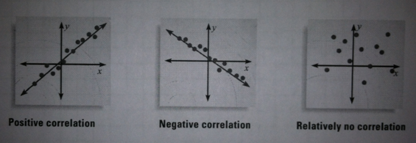

Connections
- What other sets of data could be useful when talking about correlation?
- What are some factors that could have caused your data to be wrong?

Resources

Fitting a Line to Data. (n.d.). Classzone. Retrieved April 23, 2012, from http://http://cphs.dadeschools.net/departments/mathematics/ebooks/alg1mcd/Source/LA105EAD.pdf

Line of Best Fit. (n.d.). MathBits. Retrieved April 24, 2012, from http://http://mathbits.com/mathbits/tisection/statistics1/linefit.htm

Line of Best Fit
Using the Calculator
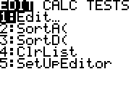

Step 1:
Put your data into your calculator by
hitting STAT and selecting 1:Edit

Step 2:
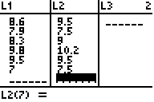
Enter your data. X values is L1 and
Y values in L2.

Step 3:
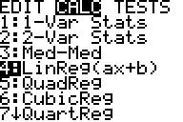
Once your data is entered hit STAT
and move right to the CALC tab. Select
4:LinReg(ax+b) and hit ENTER.

Step 4: Once you hit enter you will see you a value (slope) your b value and the correlation, r.
The closer r is to one it has a positive correlation.
The closer r is to negative one it has a negative correlation.
The closer r is or is equal to zero it has relativity no correlation.
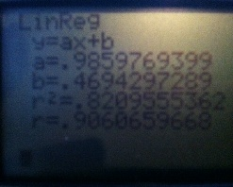

Our correlation is .906 and it is positive!

